Project Planning Phase

**Project Planning Template (Product Backlog, Sprint Planning, Stories, Story points)**

|  |  |
| --- | --- |
| Date | 18 October 2022 |
| Team ID | PNT2022TMID25500 |
| Project Name | Project - Inventory Management System For Retailes |
| Maximum Marks | 8 Marks |

Product Backlog, Sprint Schedule, and Estimation (4 Marks)

Use the below template to create product backlog and sprint schedule

|  |  |  |  |  |  |  |
| --- | --- | --- | --- | --- | --- | --- |
| **Sprint** | **Functional**  **Requirement (Epic)** | **User Story**  **Number** | **User Story / Task** | **Story Points** | **Priority** | **Team**  **Members** |
| Sprint-1 | Registration | USN-1 | As a user, I can register for the application by entering my email, password, and confirming my password. | 5 | High | Gowri sankar Hari haran Kugan |
| Sprint-1 | Confirmation | USN-2 | As a user, I will receive confirmation email once I have registered for the application | 2 | High | Hari haran Kugan Mutheswaran |
| Sprint-1 | Login | USN-3 | As a user, I can register for the application through Gmail | 8 | Low | Ganesh Hari haran  Mutheswaran |
| Sprint-1 |  | USN-4 | As a user, I can log into the application by entering email & password | 4 | Medium | Gowri sankar Mutheswaran  Ganesh |
| Sprint-2 | Dashboard | USN-5 | As a user, I can view the products which are available | 10 | High | hari haran Kugan Ganesh |
| Sprint-3 | Stock Update | USN-6 | As a user, I can add products which are not  available in the dashboard to the stock list | 6 | Medium | Mutheswaran  Gowri sankar Ganesh |
| Sprint-3 |  |  | As a user, can edit the product price details in  the inventory | 4 | High | Kugan  Hari haran |

|  |  |  |  |  |  |  |
| --- | --- | --- | --- | --- | --- | --- |
| **Sprint** | **Functional**  **Requirement (Epic)** | **User Story**  **Number** | **User Story / Task** | **Story Points** | **Priority** | **Team**  **Members** |
| sprint-3 |  | USN-7 | As a user , can click the submit bitton to update the stock inventory | 10 | Medium | Ganesh Gowri sankar |
| Sprint-4 | Contact Customer Care | USN-8 | I can be able to report any difficulties I experience as a report | 15 | HIgh | Mutheswaran Gowri sankar Ganesh Kugan  Hari haran |

Project Tracker, Velocity & Burndown Chart: (4 Marks)

|  |  |  |  |  |  |  |
| --- | --- | --- | --- | --- | --- | --- |
| **Sprint** | **Total Story Points** | **Duration** | **Sprint Start Date** | **Sprint End Date (Planned)** | **Story Points Completed (as on**  **Planned End Date)** | **Sprint Release Date (Actual)** |
| Sprint-1 | 19 | 6 Days | 24 Oct 2022 | 29 Oct 2022 | 19 | 29 Oct 2022 |
| Sprint-2 | 10 | 6 Days | 31 Oct 2022 | 05 Nov 2022 | 10 | 05 Nov 2022 |
| Sprint-3 | 20 | 6 Days | 07 Nov 2022 | 12 Nov 2022 | 20 | 12 Nov 2022 |
| Sprint-4 | 15 | 6 Days | 14 Nov 2022 | 19 Nov 2022 | 15 | 19 Nov 2022 |

Velocity:

Imagine we have a 10-day sprint duration, and the velocity of the team is 20 (points per sprint). Let’s calculate the team’s average velocity (AV) per iteration unit (story points per day)

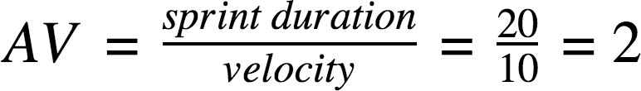

Velocity:

Average Velocity of sprin-1: AV = 19/6 = 3.16 Average Velocity of sprin-2: AV = 10/6 = 1.66 Average Velocity of sprin-3: AV = 20/6 = 3.33 Average Velocity of sprin-4: AV = 15/6 = 2.5

Burndown Chart:

A burn down chart is a graphical representation of work left to do versus time. It is often used in agile [software development](https://www.visual-paradigm.com/scrum/what-is-agile-software-development/) methodologies such as [Scrum](https://www.visual-paradigm.com/scrum/scrum-in-3-minutes/). However, burn down charts can be applied to any project containing measurable progress over time.

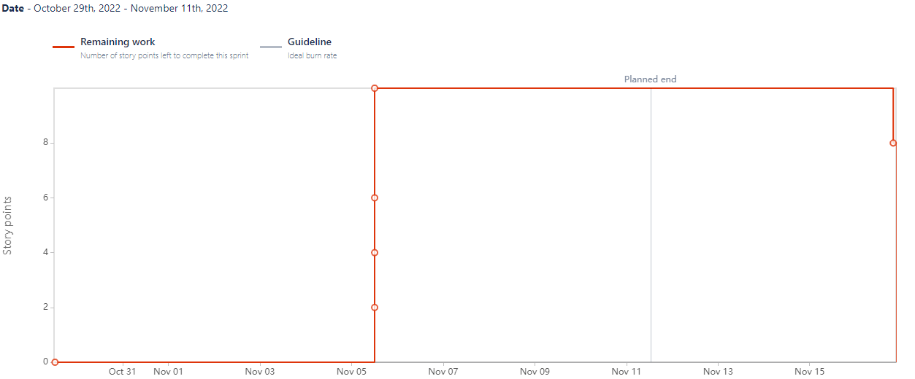

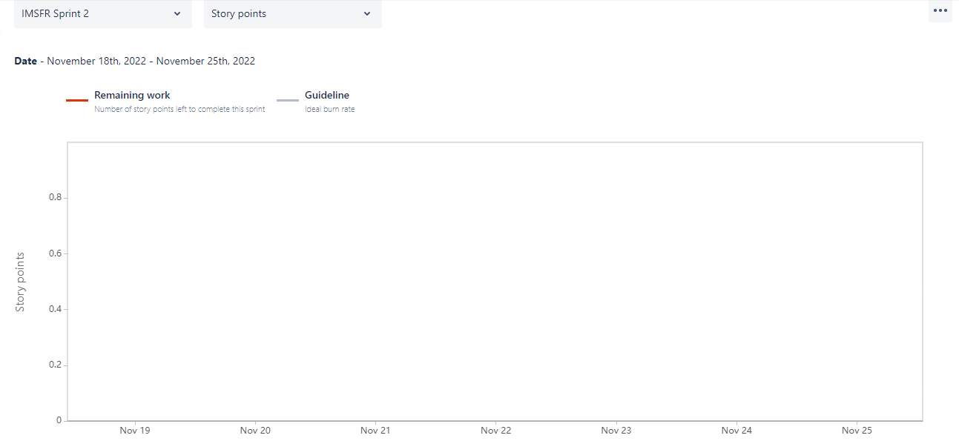

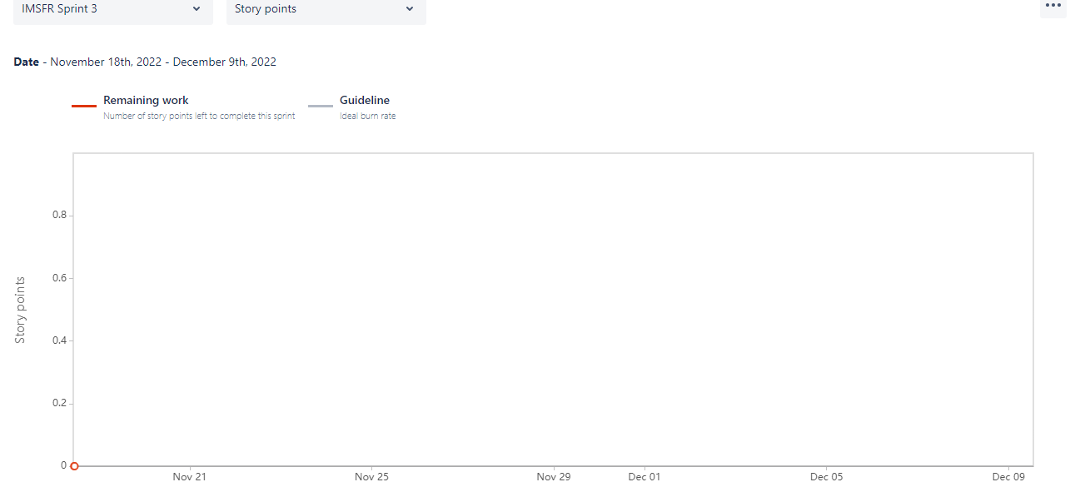

<https://www.visual-paradigm.com/scrum/scrum-burndown-chart/> <https://www.atlassian.com/agile/tutorials/burndown-charts>

Reference:

<https://www.atlassian.com/agile/project-management> <https://www.atlassian.com/agile/tutorials/how-to-do-scrum-with-jira-software> <https://www.atlassian.com/agile/tutorials/epics> <https://www.atlassian.com/agile/tutorials/sprints> <https://www.atlassian.com/agile/project-management/estimation> <https://www.atlassian.com/agile/tutorials/burndown-charts>